LAB ASSIGNMENT - 01

ON

BASIC USE OF GRAPHICS.H LIBRARY

Submitted to:

S.M. Shahzad Hossain

Lecturer

Department of Computer Science and Engineering

Daffodil International University

Submitted by:

Md. Tanvir Hossain

ID: 161-15-7157

Department of Computer Science and Engineering

Section: C



Daffodil International University

Dhaka, Bangladesh

Date of Submission: 25/05/2019

Question-1: Write a program to draw a parallelogram using only line function of graphics.h header.

Solve:

#include<graphics.h>

#include<conio.h>

main()

{

int gd=DETECT,gm;

/\* initialization of graphic mode \*/

initgraph(&gd,&gm,"C:\\TC\\BGI");

//setting color

setcolor(GREEN);

//bottom

line(10,100,200,100);

//right

line(250,10,200,100);

//top

line(250,10,60,10);

//left

line(10,100,60,10);

//naming

setcolor(WHITE);

outtextxy(50,110,"Parallelogram");

getch();

closegraph();/\* Restore orignal screen mode \*/

}

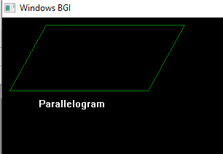

Figure-1: Parallelogram

Question-2: Write a program to draw a rhombus using only line function of graphics.h header.

Solve:

#include<graphics.h>

#include<conio.h>

main()

{

int gd=DETECT,gm;

/\* initialization of graphic mode \*/

initgraph(&gd,&gm,"C:\\TC\\BGI");

//setting color

setcolor(YELLOW);

//bottom

line(10,200,200,200);

//right

line(250,10,200,200);

//top

line(250,10,60,10);

//left

line(10,200,60,10);

//naming

setcolor(GREEN);

outtextxy(50,210,"Rhombus");

//naming-2

setcolor(WHITE);

outtextxy(300,400,"@md. tanvir hossain - 161-15-7157");

getch();

closegraph();/\* Restore orignal screen mode \*/

}

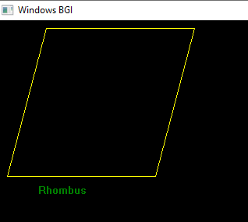

Figure-2: Rhombus